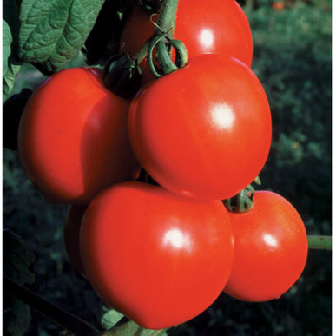
New Girl Fruits avg. 4-6 oz. and have better flavor and are more disease resistant than Early Girl. Widely adapted. High resistance to fusarium wilt races 1, 2 and verticillium wilt. Indeterminate.

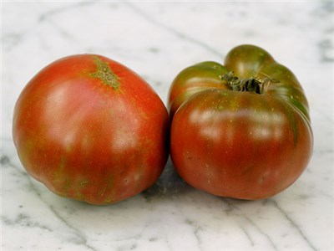
Black from Tula 70-80 days. A unique, large 8-12 oz. dark tomato exhibiting a rich, deep purplish-brown color. Some seed savers say it is the best tasting of all the dark tomatoes. Very rich, old-fashioned flavor, sweet and spicy. A rare Russian heirloom.

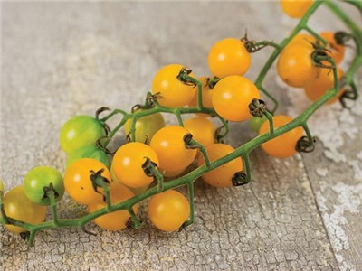
Gold Rush Currant Tiny currant tomatoes ripen a deep, rich golden orange. The fruits on this nearly wild-type tomato are just a quarter-inch in diameter, but produced on large trusses of up to a dozen fruits, with many ripening at once. A selection from renowned Dutch seedsman, the late Kees Sahin.

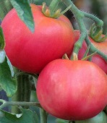
Peach Blow Sutton 80 days. Solanum lycopersicum. Open Pollinated. Plant produces good yields of 6 to 7 oz pink color peach like tomatoes. These tomatoes are very sweet and have a fuzzy skin like a peach. A heirloom variety introduced by Sutton Seeds in 1897 of England, UK. United States Department of Agriculture, PI 647508. Indeterminate.
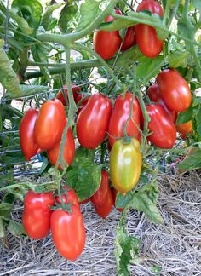
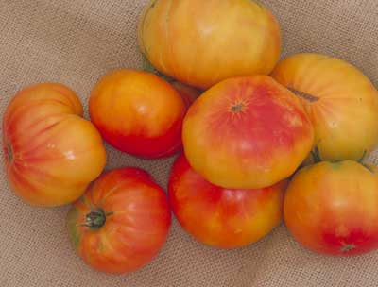
Marvel Stripe 85 days. Heirloom variety. Large yellow-orange fruits are streaked with ruby red and have a sweet, fruity taste. Tomatoes weigh about 1 lb., although they often become 2 lbs. or even more. Said to have arge harvests on vigorous vines. Indeterminate.

Inca Jewels 75 days. “Roma” style container tomatoes are bred for extra-heavy yields on space-saving 3 ft. plants. Ideal to grow in large pots or in smaller garden spaces.

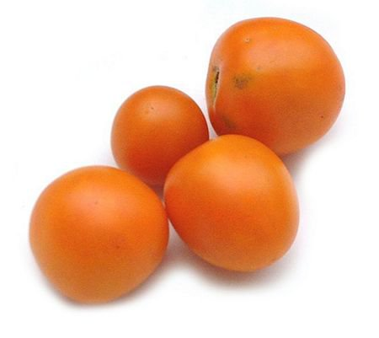

Mandarin Cross – 80 days. Golden-orange tomatoes Japanese OP variety from that dates back to 1964. Indeterminate, regular leaf plant produces medium sized, 6-10 oz, round, orange tomatoes with dense flesh and said to have exceptional flavors.

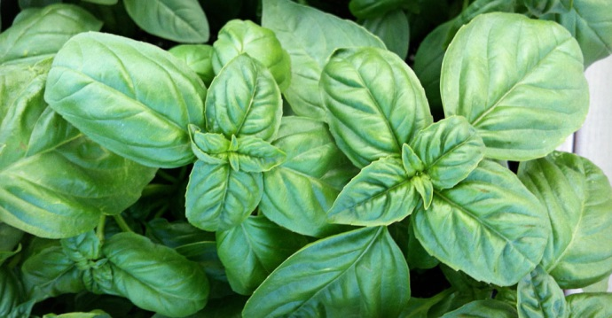
Genovese basil is a cultivar of Ocimum basilicum (sweet basil). It is one of the most popular basils for culinary use, particularly for its use in pesto, the traditional Genoese sauce.

